Computer Workshop 5: Linear models with a categorical predictor
Roos & Pinard
Last updated: 2024-08-19
Table of Contents

Workshop Structure
As always, we are using the workflow below to structure the workshops:
- Formulate a research question.
- Perform exploratory data analysis.
- Identify any hidden assumptions.
- Fit an appropriate model [Focus of today].
- Diagnose the model and check assumptions.
- Summarise the results.
- Interpret and provide inferences.

1. Formulate a Research Question
For this workshop on fitting a linear model with a single categorical explanatory variable (or “predictor”, etc), we’re going to be using a new dataset.Our dataset this week comes from Japan, specifically the Ryukyu islands, far to the south of mainland Japan. Two islands, in particular, are home to the Amami rabbit (Pentalagus furnessi), a particularly ancient species of rabbit and designated a “natural monument” of Japan, currently threatened due to the invasive Java mongoose.
We’ve been contacted by researchers in Japan asking us if we can help answer if the invasive species may be causing rabbit size to decline. For this they are providing a dataset of rabbit weights from two islands; Oshima, where mongoose are present, and Tokunoshima, where mongoose are believed to be absent. Mongoose are known to be present on Oshima (multiple captures with a control program underway) while on the smaller island of Tokunoshima there have been no reported sightings by locals of mongoose.
- weight: The weight of the Amami rabbit.
- mongoose: Whether the rabbit was on the island with mongoose present (Oshima), or not (Tokunoshima.)

2. Perform Exploratory Data Analysis
Given this is a new dataset, we need to check for any data issues. But before we begin, our colleagues in Japan email to note two data entry mistakes. In their email, they report:
Mistake 1: * The rabbit in the 7th row was actually from Oshima, not Tokunoshima.
Mistake 2: * We cannot remember which rabbit, but we accidentally added 100 to its weight.
They ask you to resolve these issues but also to check for any other possible mistakes.

Question Set One
- What mongoose value should the first mistake have?
- Which rabbit had the incorrect weight?

3. Identify Any Hidden Assumptions
Having resolved any data issues, it’s time to think more carefully about that data and identify any hidden assumptions.

Question Set Two
- Can you already identify any hidden assumptions with this dataset?
- If you have identified any issues, can we do anything about it/them?
- If there are mongoose on Tokunoshima, what effect would that have on any analysis we might perform?

4. Fit an appropriate model.
Assuming you are happy to proceed to analysis, let’s think what this model will look like:
$weight_{i}∼Normal\left(μ_{i},σ\right)$
μi=β0+β1×Presenti
Where:
- $weight_{i}$ is the weight of rabbit $i$, assumed to follow a $Normal$ distribution with a mean of $μ_{i}$ (what the model predicts for rabbit $i$) and a standard deviation of $σ$.
- $μ_{i}$ is defined by $β_{0}$ and $β_{1}$

Question Set Three
If you’re struggling to answer the questions below, you can always skip ahead to running the model, and then come back to these questions, using the model summary to help you.
- What replaces the blank part of the above equation?
- What does the parameter $β_{0}$ represent?
- What does the parameter $β_{1}$ represent?
Let’s run our linear model:
rabbit_mod <- lm(weight ~ mongoose, data = rabbit)
Having run the model, let’s see what the parameters $β_{0}$ and $β_{1}$ have been estimated as, using summary():
summary(rabbit_mod)

Question Set Four
- Replace the blank areas of the equation with the values that have now been estimated by the model.
$weight_{i}∼Normal\left(μ_{i},σ\right)$
μi=β0+β0×Presenti
- Using your completed equation from 1., what value of $μ$ (or Amami rabbit weight) would you predict if there are mongoose present?
- Using your completed equation from 1., what value of $μ$ would you predict if mongoose were absent?
- Is the presence mongoose associated with a decline in weight as the Japanese researchers hypothesised?
- Is the association sufficient to be of biological concern?

5. Diagnose the model and check assumptions.
We’ll cover this on Friday.

6. Summarise the results.
We’ll come back to “5. Diagnose the model and check assumptions.” on Friday. For today we’ll go through how to take these results and convert them into a figure.
Just like last week, we’ll use two options to plot our model results:
- Option 1: Use the ggeffects package to create the figure for you.
- Option 2: Create the prediction and figure yourself.

ggeffects
Make sure you load ggeffects (and make sure it’s installed if you didn’t do so last week):
library(ggeffects)
Then ask ggeffects to predict rabbit weight for each of our mongoose categories:
preds <- ggpredict(rabbit_mod)
Now we just need to plot it:
plot(preds)
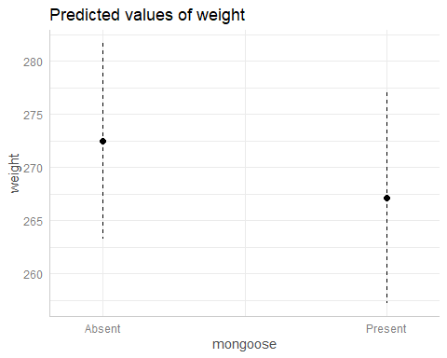
Just like last week, we get a figure quickly and easily that shows our model predictions.

Create the prediction and figure yourself.
We can also, broadly, repeat the process we used last week, with only a few minor tweaks to account for the different type of explanatory varibale (from continuous to categorical).
For starters, when we make our fake dataset, the values of mongoose need to only be Present or Absent (just like in our actual dataset). We don’t need to create a range of values to predict over this time. To create our mongoose variable, we can either use c("Absent", "Present") or we can use the unique() function that you may have used in the very first Workshop. unique() will return all unique values within a column of data, so unique(rabbit$mongoose), will also return "Absent" and "Present". The benefit of using unique() is when we have categorical variables with many groups (or levels) and it becomes a real pain to write out all of the different groups.
Let’s use unique() now to create our fake dataset to predict from:
fake <- data.frame(
mongoose = unique(rabbit$mongoose)
)
fake
Giving us a very simple dataset with just mongoose and two rows. One for Absent and one for Present.
Last week we used our fake dataset to only make a prediction for the “mean fit” (i.e. predicted boto length). This week we’re also going to include uncertainty, specifically, we’re going to also include 95% confidence intervals.
To do so, we need to add in some additional steps. For starters, because predict() is going to give us both the fit (i.e. predicted rabbit weight), but also se.fit (i.e. the standard error for the fit), we can’t immediately add this to our fake dataset.
Instead, we’ll just put the output from predict() into a temporary dataset, which we’ll arbitrarily call preds:
preds <- predict(rabbit_mod, newdata = fake, se.fit = TRUE)
The next part is the same as last week, just with an extra step. We can just go into the preds object and extract $fit, and include this in our fake dataset:
fake$fit <- preds$fit

Confidence intervals
This next part is new. We’re going to use the standard error of the fit to calculate the 95% confidence intervals. If you need a reminder of what 95% CI are, then have a quick look at the lecture material.
The important thing to remember is that 95% CI take the standard error, multiplied by 1.96, and either subtract this from fit to get our lower 95% CI, or we add it to fit to get our upper 95% CI. Here’s how we do that:
fake$low95 <- preds$fit - 1.96 * preds$se.fit
fake$upp95 <- preds$fit + 1.96 * preds$se.fit
Now our fake dataset has all the values we need to do plot our results, using geom_errorbar() to add in the error bars to show our 95% CI:
ggplot(fake) +
geom_errorbar(aes(x = mongoose, ymin = low95, ymax = upp95)) +
geom_point(aes(x = mongoose, y = fit)) +
labs(x = "Java mongoose",
y = "Predicted weight of rabbits (g)") +
theme_minimal()
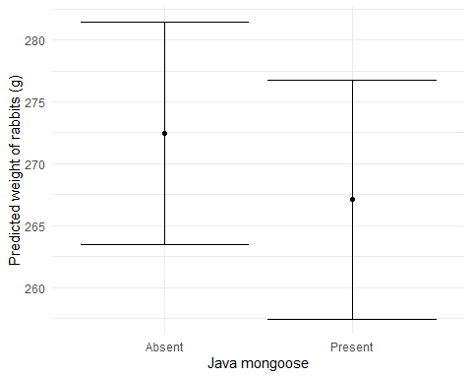

The full workflow
Here’s the entire workflow for the above analysis
# Deon Roos
# Analysis of Amami rabbit weight in relation to mongoose presence
# Load data
setwd("my/file/path")
rabbit <- read.table("rabbit.txt", header = T)
# EDA
summary(rabbit)
str(rabbit)
ggplot(rabbit) +
geom_histogram(aes(x = weight))
ggplot(rabbit) +
geom_point(aes(x = mongoose, y = weight))
# Correcting 2 data entries identified in EDA and through communication with researchers
rabbit$mongoose[7] <- "Present"
rabbit$weight[rabbit$weight > 350] <- rabbit$weight[rabbit$weight > 350] - 100
# Concerns prior to modelling
# Unclear if mongoose on one island are actually absent or just not detected, or not reported
# Ideally this would be resolved before continuing with analysis but we are unable to
# Analysis
rabbit_mod <- lm(weight ~ mongoose, data = rabbit)
# Diagnostics
# Covered in next workshop
# Inference
summary(rabbit_mod)
fake <- data.frame(mongoose = unique(rabbit$mongoose))
preds <- predict(rabbit_mod, newdata = fake, se.fit = TRUE)
fake$fit <- preds$fit
fake$low95 <- preds$fit - 1.96 * preds$se.fit
fake$upp95 <- preds$fit + 1.96 * preds$se.fit
ggplot(fake) +
geom_errorbar(aes(x = mongoose, ymin = low95, ymax = upp95)) +
geom_point(aes(x = mongoose, y = fit)) +
labs(x = "Java mongoose",
y = "Predicted weight of rabbits (g)") +
theme_minimal()

Question Set Five
- Once you’ve completed this analysis (not including model diagnostics, which we’ll cover on Friday), in groups, discuss whether you think these results should be shared with the local government as evidence to help them decide if mongoose eradication should continue or not.

A new challenger
Once you’re finished with the Amami rabbit dataset, move on to the lemur.txt dataset on MyAberdeen. This dataset comes from researchers who are interested in understanding how activity levels (i.e. how many hours a group of lemurs are active for in a day), varies across four habitat types.
The data contains:
- activity - the number of hours lemurs were active for (measured to two decimal places)
- habitat - one of four habitat types; Rainforest, Dry Forest, Spiny Forest, and Mangrove.
Go through the workflow you’ve just refined for fitting a linear model with a categorical explanatory variable and see which habitat type lemurs are most active in.

Assumption table
Assumption | Description | Example of Violation
1. Validity | The data is able to answer the research question effectively. | Using IQ to measure overall intelligence (what does IQ even measure?).
2. Representativeness | The data reflects the population or group being studied. | Using survey data from a rural area to draw conclusions about an urban population.
3. Additivity | Effects of predictors are additive and there are no interactions between them. | Assuming that study hours and sleep hours independently affect exam scores without considering their combined effect (imagine a Venn diagram with study and sleep overlapping).
4. Linearity | The relationship between predictors and the outcome is linear. | Assuming plant growth will continue to increase indefinitely without ever levelling out.
5. Independence of Errors | Observations are independent of each other. (Related to residual errors.) | If modelling height, the data come from the same group of children over time.
6. Equal Variance of Errors | Residuals have constant variance across all levels of predictors (“homoscedasticity”). (Related to residual errors.) | If modelling income, variability in salaries is not the same across all levels of a company’s hierarchy.
7. Normality of Errors | Residuals should be normally distributed. (Related to residual errors.) | If modelling income, the presence of any extremely wealthy individuals will be hard for the model to understand and explain.

